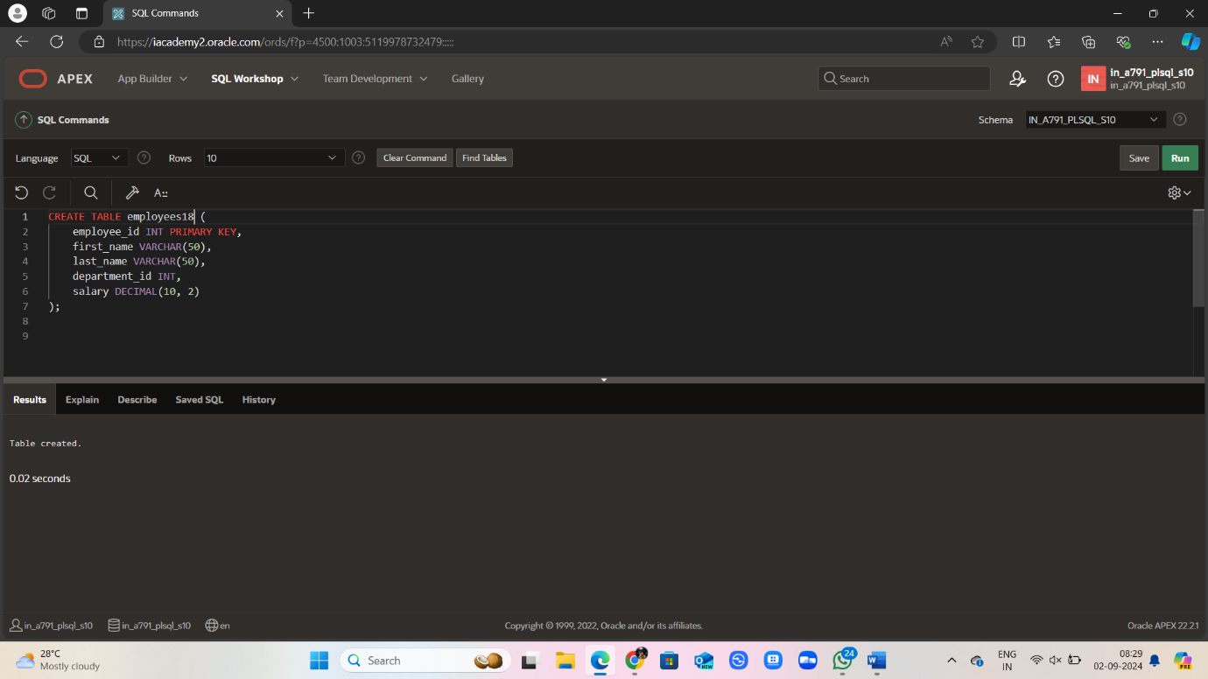

CREATE TABLE employees18 (

employee_id INT PRIMARY KEY,

first_name VARCHAR(50),

last_name VARCHAR(50),

department_id INT,

salary DECIMAL(10, 2)

);

INSERT INTO employees18 (employee_id, first_name, last_name, department_id, salary)

VALUES

(1, 'John', 'Doe', 50, 5000.00),

(2, 'Jane', 'Smith', 50, 6000.00),

(3, 'Michael', 'Johnson', 60, 5500.00),

(4, 'Emily', 'Davis', 60, 8000.00),

(5, 'David', 'Wilson', 70, 4000.00),

SELECT department_id, MIN(salary)

FROM employees18

GROUP BY department_id

HAVING MIN(salary) >

(SELECT MIN(salary)

FROM employees18

WHERE department_id = 50);

